

*PROJECT REPORT ON PCM USING MATLAB*

Project Guide: Shouvik Sarkar

Name: Abhishek Kumar Simra

Email ID: [abhisheksimra12@gmail.com](mailto:abhisheksimra12@gmail.com)

PCM USING MATLAB

**A Project Report for Industrial Internship/Major Project/Minor Project**

###### ***Submitted by***

ABHISHEK KUMAR SIMRA

***In the partial fulfillment for the award of the degree of***

##### **B.Tech**

##### In the

Electronics and communication Engineering

Department

R.V.S COLLEGE OF ENGINEERING & TECHNOLOGY, JAMSHEDPUR



at

**Ardent Computech Pvt. Ltd.**





**CERTIFICATE FROM SUPERVISOR**

This is to certify that *ABHISHEK KUMAR SIMRA*  successfully completed the project titled **"PCM**" under my supervision during the period from <start month> to <end month> that is in partial fulfillment of requirements for the award of the B.Tech/MCA/BCA and submitted to the B.Tech/MCA/BCA Department of “R.V.S COLLEGE OF ENGINEERING & TECHNOLOGY, JAMSHEDPUR”.

___________________________

*Signature of the Supervisor*

**Date:**

**Name of the Project Supervisor:** Shouvik Sarkar

*OBJECTIVE*

1. To generate sampled PCM signal using MATLAB software.
2. To perform Pulse Code Modulation system using MATLAB.
3. To Observe the difference in transmitted signal and received signal from graph.

ACKNOWLEDGEMENT

The achievement that is associated with the successful completion of any task would be incomplete without mentioning the names of those people whose endless cooperation made it possible. Their constant guidance and encouragement made all our efforts successful.

We take this opportunity to express our deep gratitude towards our project mentor, *[Name of the faculty]* for giving such valuable suggestions, guidance and encouragement during the development of this project work.

Last but not the least we are grateful to all the faculty members of Ardent Computech Pvt. Ltd. for their support.

CONTENT/INDEX

|  |  |  |
| --- | --- | --- |
| SL.NO. | TOPICS | PAGE NO. |
| 1. | INTRODUCTION | 8 |
| 2. | THEORY/TECHNOLOGY | 9-15 |
| 3. | COMPONENTS REQUIRED | 16 |
| 4. | DISCRIPTION OF COMPONENTS | 17-19 |
| 5. | DATA FLOW DIAGRAM | 20 |
| 6. | BLOCK DIAGRAM | 21 |
| 7. | PROJECT CODE | 22-24 |
| 8. | PROJECT PICTURES | 25-29 |
| 9. | PROJECT RESULT/DISCUSSION | 30 |
| 10. | FUTURE SCOPE | 31 |
| 11. | CONCLUTION | 32 |
| 12. | REFERENCES | 33 |

INTRODUCTION:

The Pulse-code-modulation Project is made is to make the work easy to study the pulses of the input signal at the transmitter side i.e., the wave input, them the signal is modulated at different frequency and amplitude and the modulated wave is generated then the wave is sent to the receiver end, at receiver end the signal is received in the form of modulated or coded form, then at receiver end the signal is reconstructed and the input signal is regenerated by the receiver .

In this project we are digitally generating the sine wave for PCM, then these sine waves are modulated first, then these modulated waves are passed for demodulation, and from these demodulated waves the receiver side signal is generated digitally without using any hard ware component.

This project reduce the time to study the wave form in PCM as it shows the wave quickly where as in oscilloscope we have to adjust the frequency and amplitude to get the sine wave of the PCM signals. Where as in GUI will reduce the time and give the result correctly.

THEORY/TECHNOLOGY:

Pulse Code Modulation:

Pulse-code modulation (PCM) is a method used to [digitally](https://en.wikipedia.org/wiki/Digital_signal_(signal_processing)) represent sampled [analog signals](https://en.wikipedia.org/wiki/Analog_signal).

Pulse Code Modulation Pulse Code Modulation (PCM) is the digitally encoded modulation technique that is commonly used for digital transmission. With PCM, the pulses are of fixed length and fixed amplitude. PCM is a binary system where a pulse or lack of pulse within a prescribed time slot represents either a logic 1 or a logic 0 condition.

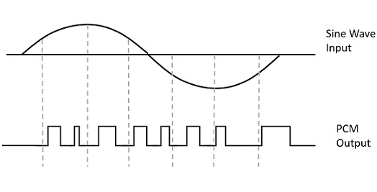

Instead of a pulse train, PCM produces a series of numbers or digits, and hence this process is called as digital. Each one of these digits, though in binary code, represent the approximate amplitude of the signal sample at that instant.

Basic Elements of PCM

The transmitter section of a Pulse Code Modulator circuit consists of Sampling, Quantizing and Encoding, which are performed in the analog-to-digital converter section. The low pass filter prior to sampling prevents aliasing of the message signal.

The basic operations in the receiver section are regeneration of impaired signals, decoding, and reconstruction of the quantized pulse train. Following is the block diagram of PCM which represents the basic elements of both the transmitter and the receiver sections.

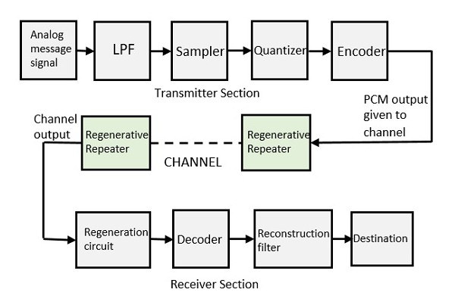

Low Pass Filter

This filter eliminates the high frequency components present in the input analog signal which is greater than the highest frequency of the message signal, to avoid aliasing of the message signal.

Sampler

This is the technique which helps to collect the sample data at instantaneous values of message signal, so as to reconstruct the original signal. The sampling rate must be greater than twice the highest frequency component W of the message signal, in accordance with the sampling theorem.

Quantizer

Quantizing is a process of reducing the excessive bits and confining the data. The sampled output when given to Quantizer, reduces the redundant bits and compresses the value.

Encoder

The digitization of analog signal is done by the encoder. It designates each quantized level by a binary code. The sampling done here is the sample-and-hold process. These three sections LPF,Sampler,andQuantizerLPF,Sampler,andQuantizer will act as an analog to digital converter. Encoding minimizes the bandwidth used.

Regenerative Repeater

This section increases the signal strength. The output of the channel also has one regenerative repeater circuit, to compensate the signal loss and reconstruct the signal, and also to increase its strength.

Decoder

The decoder circuit decodes the pulse coded waveform to reproduce the original signal. This circuit acts as the demodulator.

Reconstruction Filter

After the digital-to-analog conversion is done by the regenerative circuit and the decoder, a low-pass filter is employed, called as the reconstruction filter to get back the original signal.

Hence, the Pulse Code Modulator circuit digitizes the given analog signal, codes it and samples it, and then transmits it in an analog form. This whole process is repeated in a reverse pattern to obtain the original signal.

Sampling is defined as, “The process of measuring the instantaneous values of continuous-time signal in a discrete form.”

Sample is a piece of data taken from the whole data which is continuous in the time domain.

When a source generates an analog signal and if that has to be digitized, having 1s and 0s i.e., High or Low, the signal has to be discretized in time. This discretization of analog signal is called as Sampling.

The following figure indicates a continuous-time signal x(t) and a sampled signal xs(t). When x tt is multiplied by a periodic impulse train, the sampled signal xs(t) is obtained.

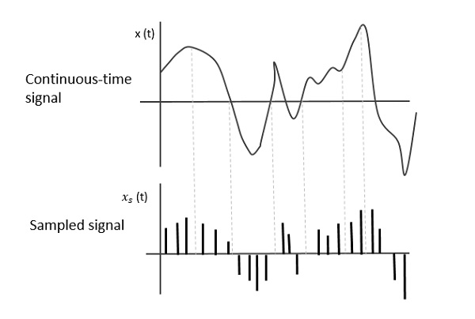

## Sampling Rate

To discretize the signals, the gap between the samples should be fixed. That gap can be termed as a sampling period Ts.

Sampling Frequency = 1Ts = fs Sampling Frequency=1Ts=fs

Where,

* Ts is the sampling time
* fs is the sampling frequency or the sampling rate

Sampling frequency is the reciprocal of the sampling period. This sampling frequency, can be simply called as Sampling rate. The sampling rate denotes the number of samples taken per second, or for a finite set of values.

For an analog signal to be reconstructed from the digitized signal, the sampling rate should be highly considered. The rate of sampling should be such that the data in the message signal should neither be lost nor it should get over-lapped. Hence, a rate was fixed for this, called as Nyquist rate.

## Quantizing an Analog Signal

* The analog-to-digital converters perform this type of function to create a series of digital values out of the given analog signal. The following figure represents an analog signal. This signal to get converted into digital, has to undergo sampling and quantizing.

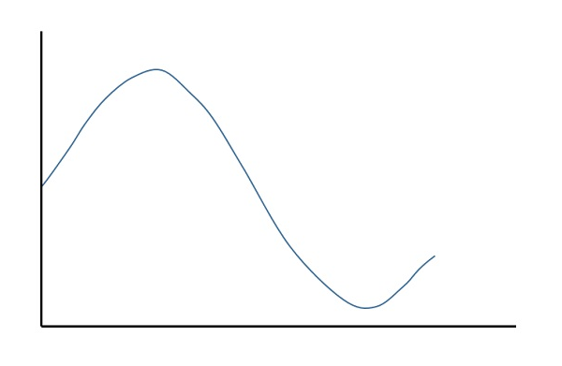

* The quantizing of an analog signal is done by discretizing the signal with a number of quantization levels. Quantization is representing the sampled values of the amplitude by a finite set of levels, which means converting a continuous-amplitude sample into a discrete-time signal.
* The following figure shows how an analog signal gets quantized. The blue line represents analog signal while the brown one represents the quantized signal.
* 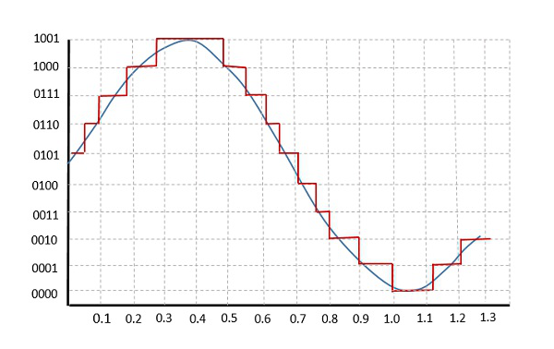
* Both sampling and quantization result in the loss of information. The quality of a Quantizer output depends upon the number of quantization levels used. The discrete amplitudes of the quantized output are called as representation levels or reconstruction levels. The spacing between the two adjacent representation levels is called a quantum or step-size.
* The following figure shows the resultant quantized signal which is the digital form for the given analog signal.

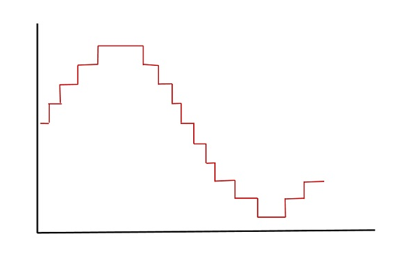

* This is also called as Stair-case waveform, in accordance with its shape.

COMPONENTS REQUIRED:

* 1. Hardware Required
     1. Computer system – Intel® core i5-8250U CPU @ 1.60GHz 8GB RAM, 240Gb-SSD, 1Tb-HDD
  2. Software Required
     1. Operating System – Windows 10 Home
     2. Matlab Software – 2020a
  3. Matlab Toolbox Required
     1. GUI toolbox

## DISCRIPTION OF COMPONENTS:

## Computer System:

A computer system is a basic, complete and functional hardware and software setup with everything needed to implement computing performance.

That’s the basic working definition of the computer system as we know it, but it has gone through a lot of formal changes over the past few decades.

**Operating System**:

An operatingsystem (OS) is [system software](https://en.wikipedia.org/wiki/System_software) that manages [computer hardware](https://en.wikipedia.org/wiki/Computer_hardware), [software](https://en.wikipedia.org/wiki/Computer_software) resources, and provides common [services](https://en.wikipedia.org/wiki/Daemon_(computing)) for [computer programs](https://en.wikipedia.org/wiki/Computer_program).

[Time-sharing](https://en.wikipedia.org/wiki/Time-sharing) operating systems [schedule tasks](https://en.wikipedia.org/wiki/Scheduler_(computing)) for efficient use of the system and may also include accounting software for cost allocation of [processor time](https://en.wikipedia.org/wiki/Scheduling_(computing)), [mass storage](https://en.wikipedia.org/wiki/Mass_storage), printing, and other resources.

**MATLAB SOFTWARE:**

MATLAB combines a desktop environment tuned for iterative analysis and design processes with a programming language that expresses matrix and array mathematics directly. It includes the [Live Editor](https://www.mathworks.com/products/matlab/live-editor.html) for creating scripts that combine code, output, and formatted text in an executable notebook.

MATLAB is a [multi-paradigm](https://en.wikipedia.org/wiki/Multi-paradigm_programming_language) [numerical computing](https://en.wikipedia.org/wiki/Numerical_analysis) environment and [proprietary programming language](https://en.wikipedia.org/wiki/Proprietary_programming_language) developed by [MathWorks](https://en.wikipedia.org/wiki/MathWorks). MATLAB allows [matrix](https://en.wikipedia.org/wiki/Matrix_(mathematics)) manipulations, plotting of [functions](https://en.wikipedia.org/wiki/Function_(mathematics)) and data, implementation of [algorithms](https://en.wikipedia.org/wiki/Algorithm), creation of [user interfaces](https://en.wikipedia.org/wiki/User_interface), and interfacing with programs written in other languages.

Although MATLAB is intended primarily for numerical computing, an optional toolbox uses the [MuPAD](https://en.wikipedia.org/wiki/MuPAD" \o "MuPAD) [symbolic engine](https://en.wikipedia.org/wiki/Computer_algebra_system) allowing access to [symbolic computing](https://en.wikipedia.org/wiki/Symbolic_computing) abilities. An additional package, [Simulink](https://en.wikipedia.org/wiki/Simulink), adds graphical multi-domain simulation and [model-based design](https://en.wikipedia.org/wiki/Model-based_design) for [dynamic](https://en.wikipedia.org/wiki/Dynamical_system) and [embedded systems](https://en.wikipedia.org/wiki/Embedded_system).

The MATLAB application is built around the MATLAB programming language. Common usage of the MATLAB application involves using the "Command Window" as an interactive mathematical [shell](https://en.wikipedia.org/wiki/Command_line_interface) or executing text files containing MATLAB code.

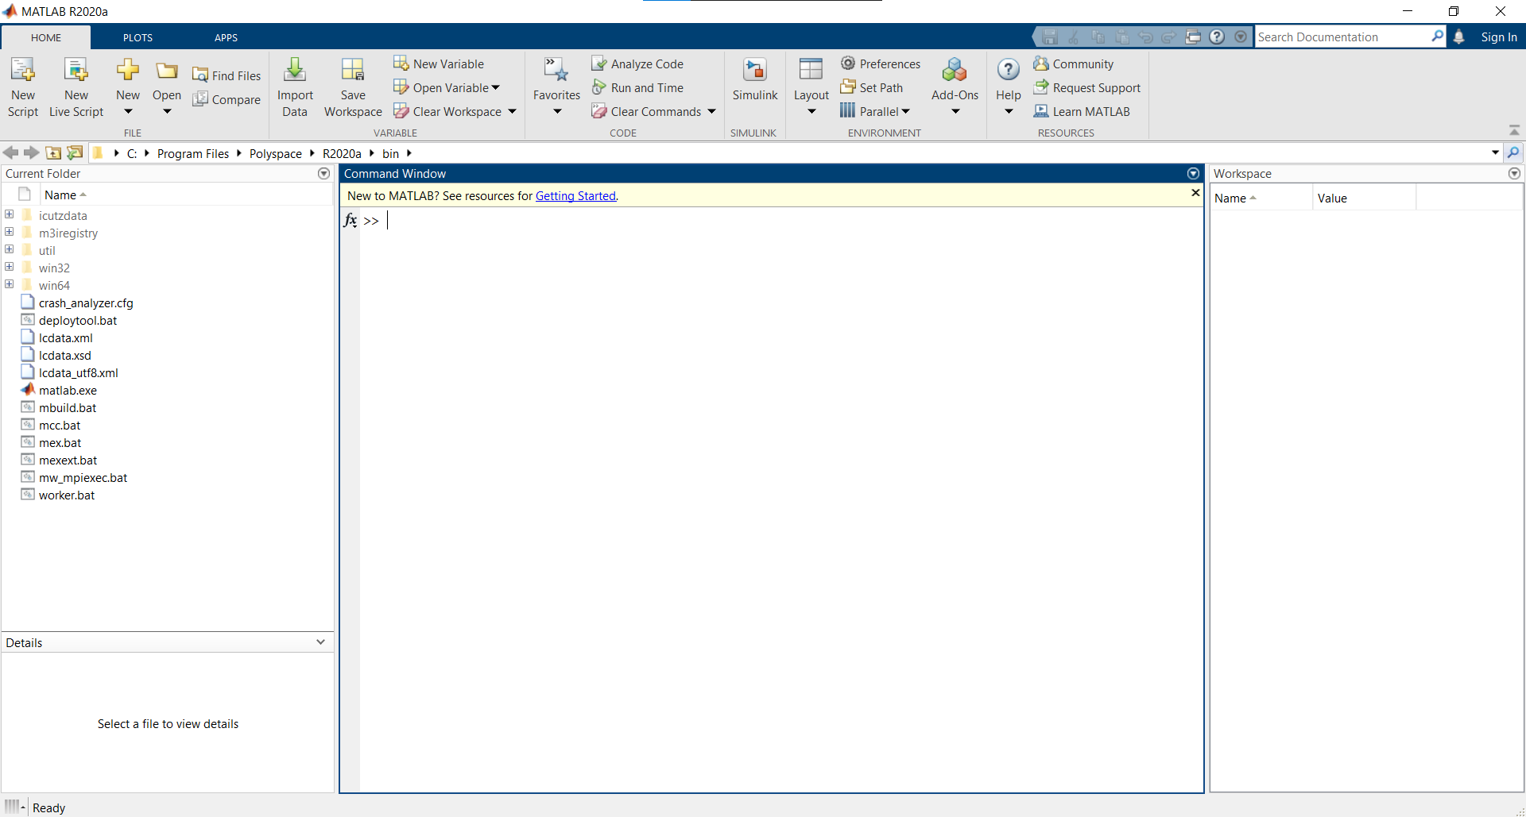

**GUI TOOLBOX:**

This toolbox provides tools to create sophisticated MATLAB graphical user interfaces that resize gracefully. The classes supplied can be used in combination to produce virtually any user interface layout.

* Arrange MATLAB user interface components horizontally, vertically or in grids  
* Mix fixed- and variable-size components  
* Resize components interactively by dragging dividers  
* Show and hide components using tabs and panels  
* Show part of a large component in a scrollable panel

This toolbox was developed by David Sampson and Ben Tordoff from the group at MathWorks.

This version is for MATLAB R2014b and later.

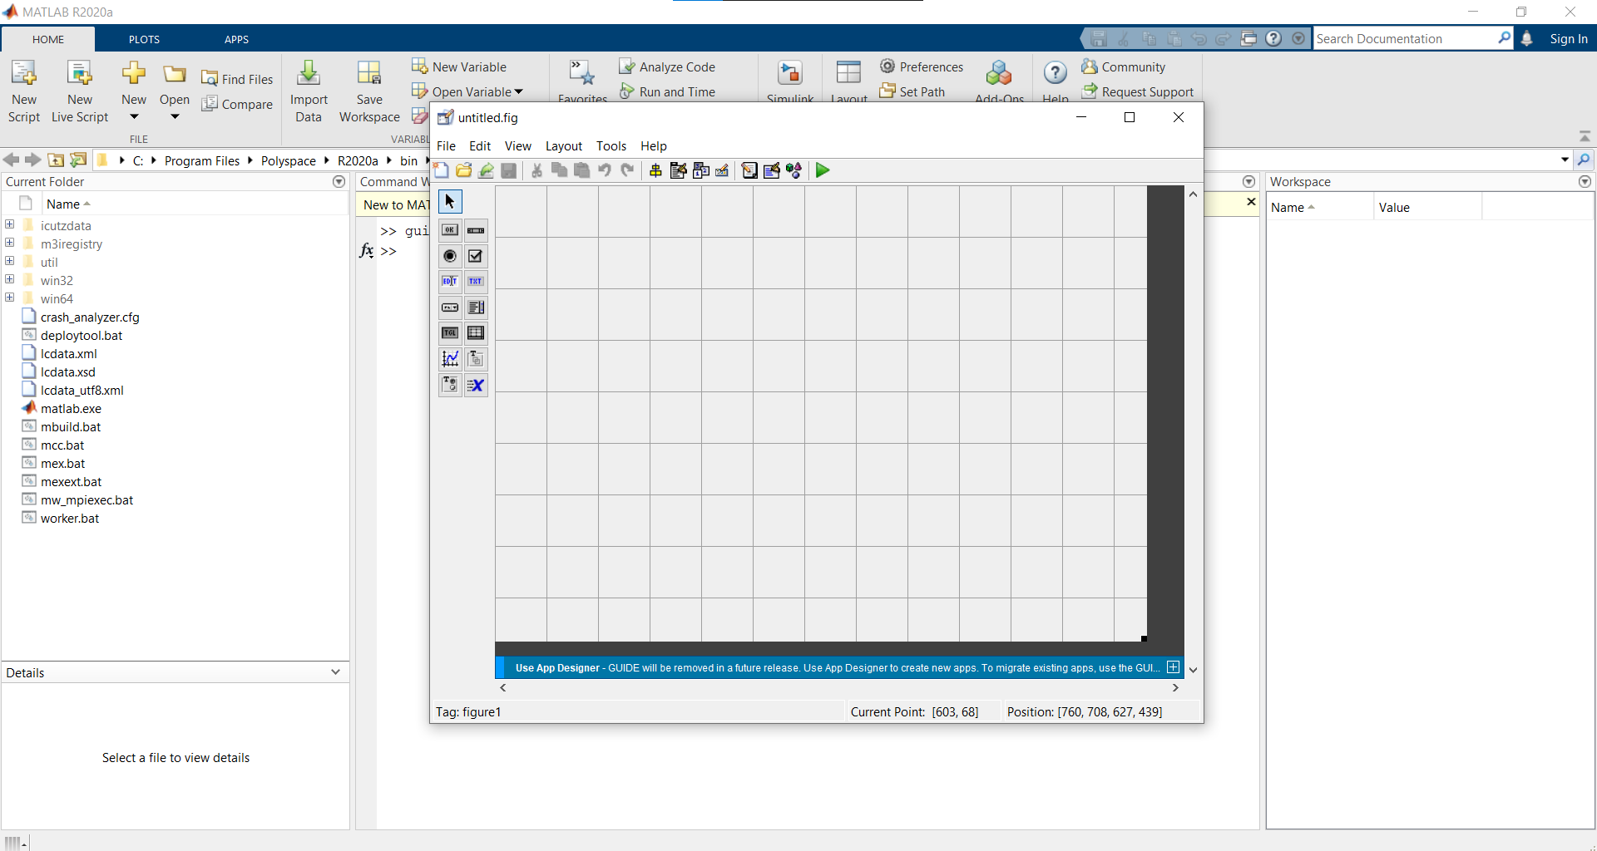

DATA FLOW DIAGRAM:

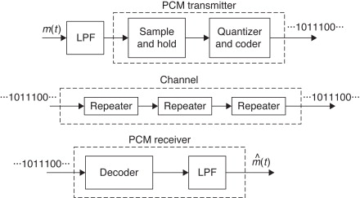

BLOCK DIAGRAM:



PROJECT CODE:

**CODES USED TO MAKE THE PROJECT:**

%PCM

% %Analog signal

c=get(handles.edit1,'string');

d=get(handles.edit2,'string');

a=str2double(c); %amplitude

f=str2double(d); %frequncy

fs=1000*f; % Nyquist sampling rate

t=0:1/fs:1; %time

x=a*sin(2*pi*f*t);

% original signal

axes(handles.axes1)

plot(t,x);

title('Original Signal');

xlabel('Time');

ylabel('Amplitude')

guidata(hObject,handles)

%level shifting

xq=x+a;

% Quantization

q_op=round(xq);

% Transmited signal

axes(handles.axes2)

plot(t,q_op);

title('Transmited signal');

xlabel('Time');

ylabel('Amplitude')

guidata(hObject,handles)

%decimal to binnary convertion

enco=de2bi(q_op,'left-msb');

% pcm reciver

deco=bi2de(enco,'left-msb');

%shifting the amplitude level to the original value

xr=deco-a;

% reconstructed signal

axes(handles.axes3)

plot(t,xr);

title('Reconstructed Signal');

xlabel('Time');

ylabel('Amplitude')

guidata(hObject,handles)

% low pass filtering

[num den]=butter(5,4*f/fs); %butterworth LPF

rec_op=filter(num,den,xr); %smoothing

%recived signal

axes(handles.axes4)

plot(t, rec_op);

xlabel('Time');

ylabel('Amplitude');

title('Recieved signal');

guidata(hObject,handles)

PROJECT PICTURES:

1. **Coding Part:**

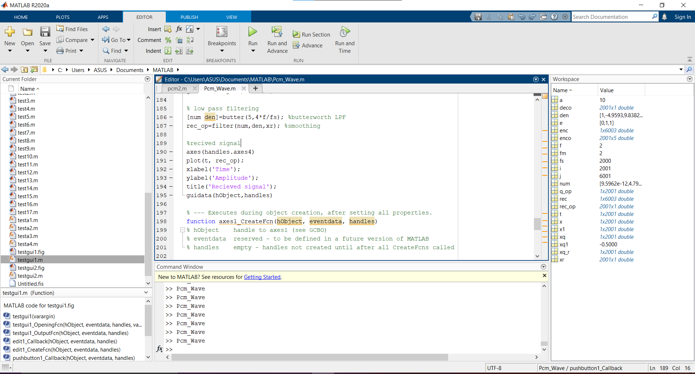

1. **Run Part:**

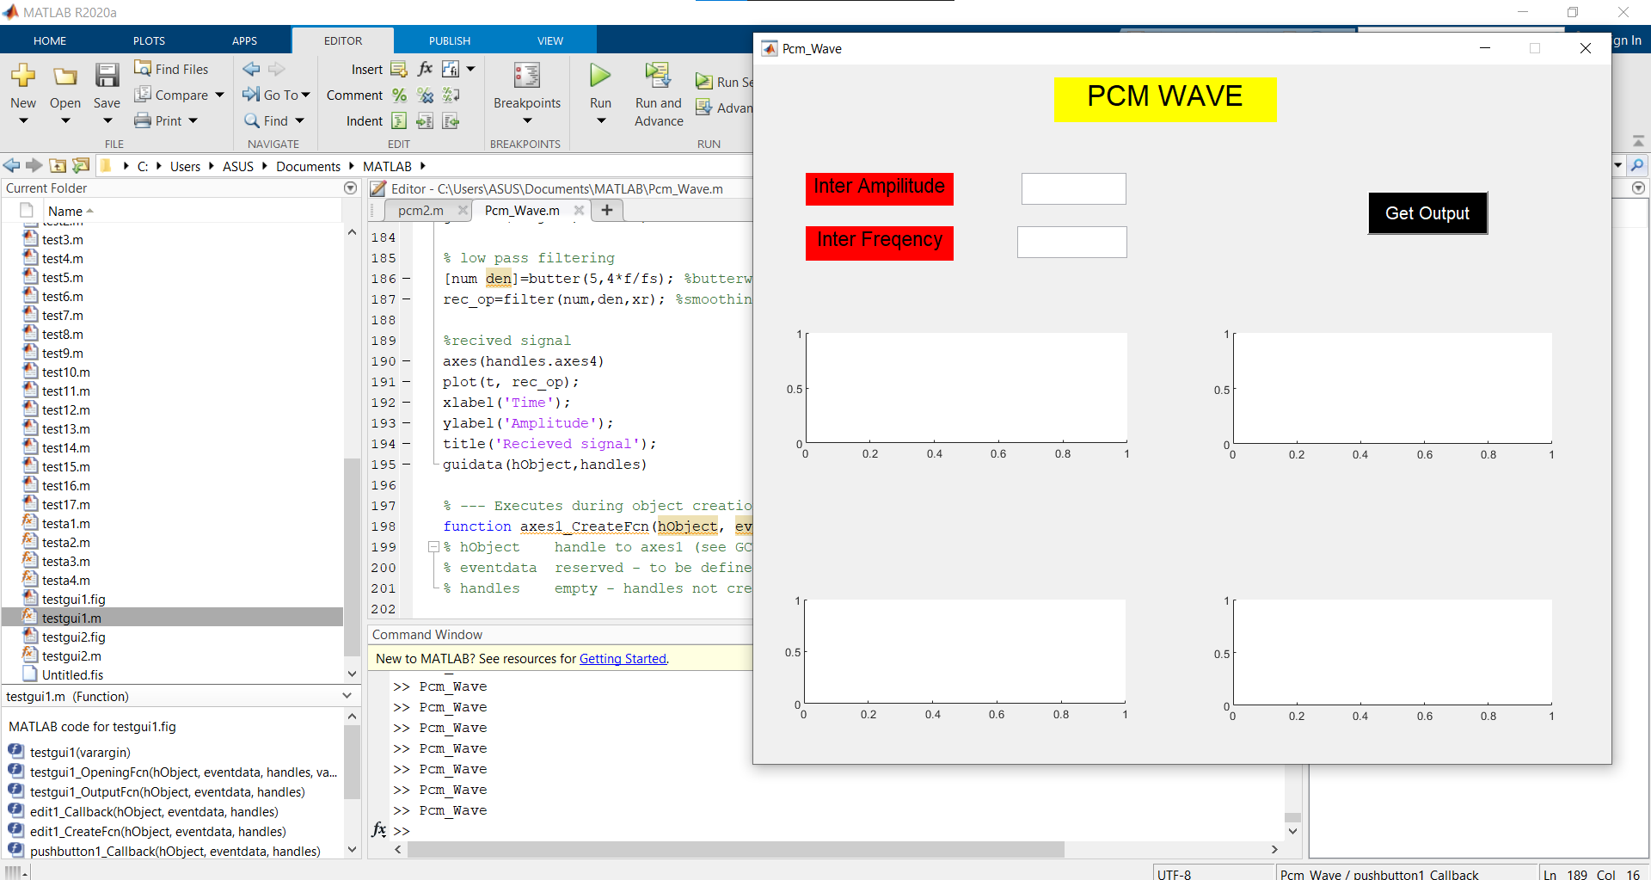

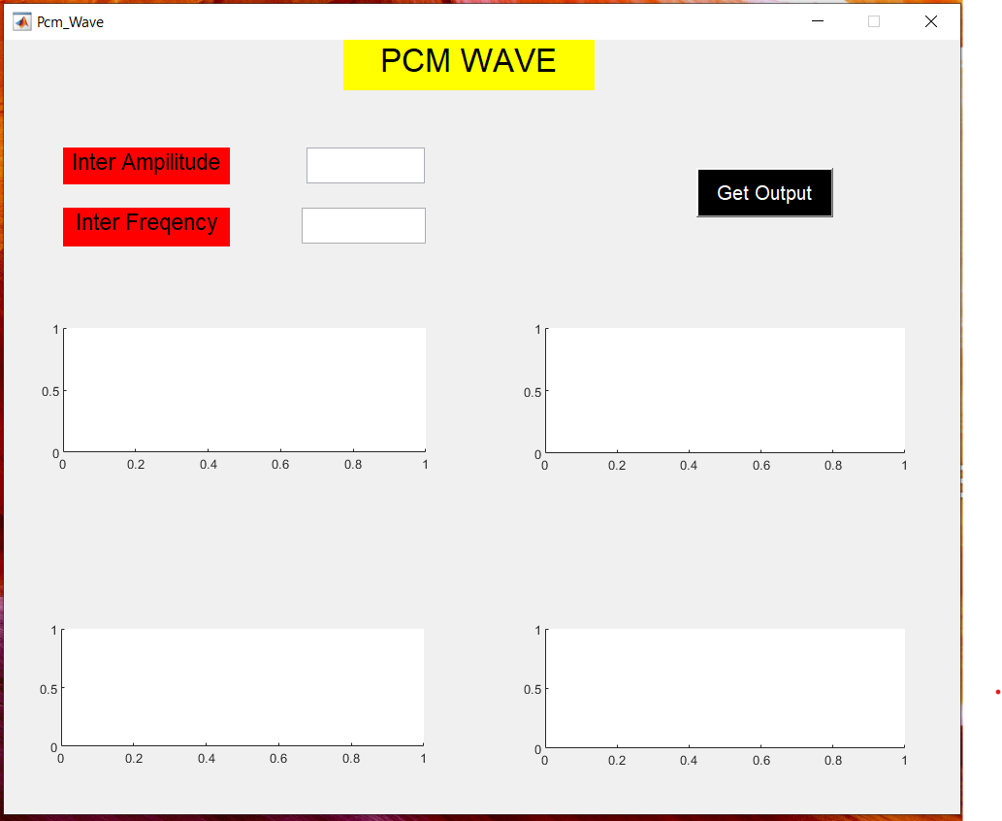

1. **Output Part:**

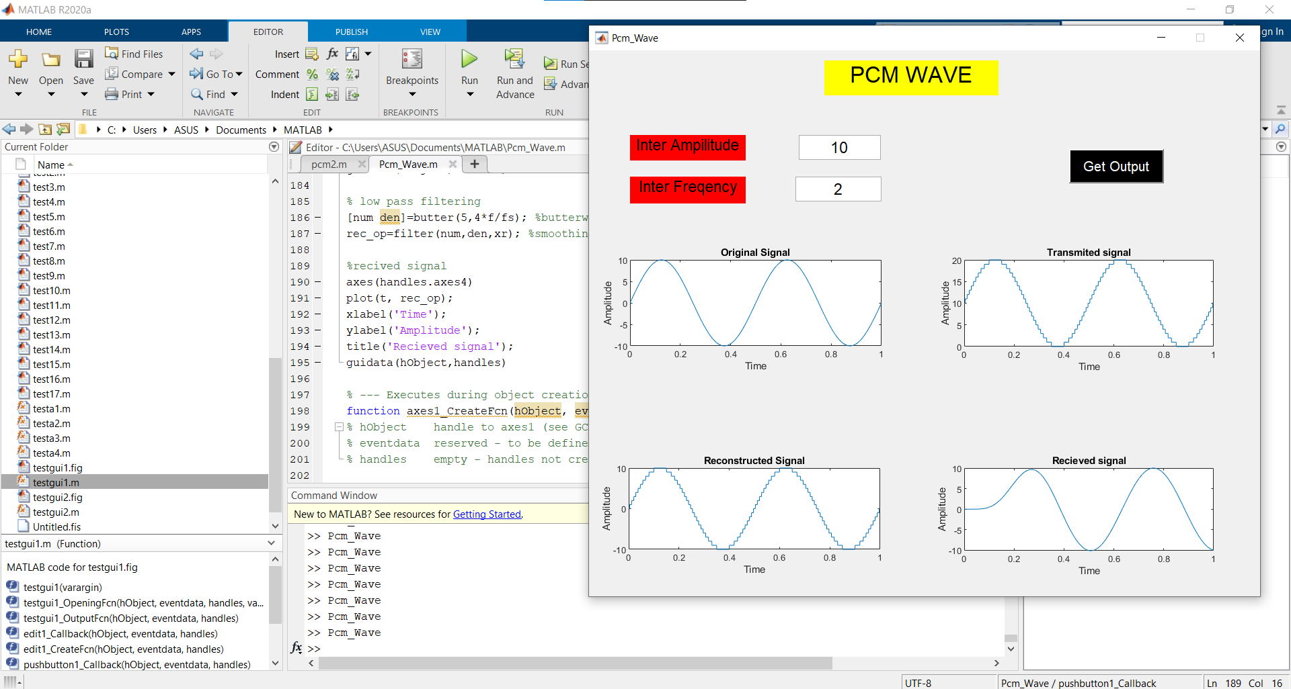

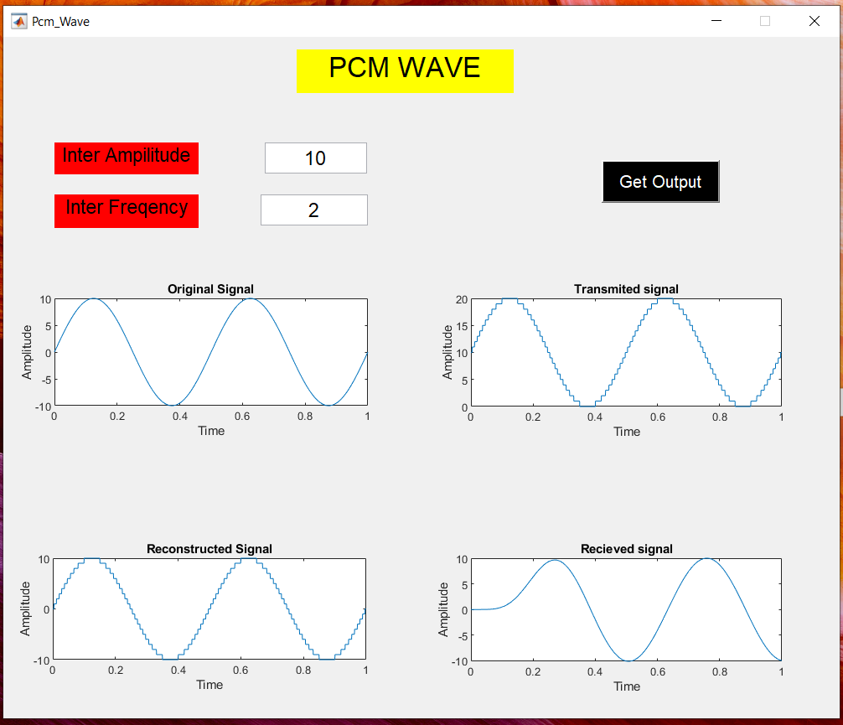

PROJECT RESULT/DISCUSSION:

The Result of the project is that we have observed the pcm sine wave as the output in the graph form and were able to study the graph and get the output of the pcm wave.

This project has reduce the work to set oscilloscope, adjust the frequency and amplitude to get the pcm sine wave to study the characteristics of the wave and the difference in the input and output wave form.

The project can replace the oscilloscope to get the wave form of the pcm sine wave form and reduce the time to compute and study the PCM sine wave structure.

FUTURE SCOPE:

The future scope of this project is to make the study of the PCM sine wave form easy and reduce the work load to get the perfect wave form of the PCM sine wave.

This project can also reduce the setup size and equipment required to get the pcm sine wave form and the study of wave form can be done by the use of this project only.

This project will reduce the cost of the equipment and man power as the study can be done easy and a single person can only take the wave form of the pcm, and it will also reduce the work of the person to go to the desired place to take the wave form, as the person can know the wave form of pcm sine wave by knowing the frequency and amplitude of wave only.

CONCLUTION:

As an undergraduate of the KOLHAN University. I would like to say that this internship program is an excellent opportunity which helps to enhance and develop my skills abilities and knowledge. I am grateful to the ARDENT COMPUTECH for the arrangement of online internship program for us in this pandemic of COVID-19.

The main objective of the internship is to provide an opportunity to know more about MATLAB and its USES. It has helped me a lot to know about the various features of MATLAB and its Use in various fields.

The detailed explanation of MATLAB and its various toolboxes, helped in enhancing our subject knowledge and skills.

REFERENCES:

The references are:

1. **Youtube**
2. **Google**
3. **Wikipedia**
4. **Tutorials point**

**THANK YOU**